Parveen Dhawan
ACTIVITY SHEET CLASS-IV
LESSON-15 FROM MARKET TO HOME
- Why does Vaishali’s father sprinkle water on previous day’s vegetables?
A.______________________________________________________________________________________________________________________________
- Why does Chhotu go to the bazaar?
A.______________________________________________________________________________________________________________________________
- Collect pictures of fruits and vegetables. Make a collage of it in the space given below.

- Given below are names of some fruits and vegetables. Write their names in your local language:
Fruits | Vegetables
- Apple __________________ | Onion _____________________
- Mango ____________________ | Potato ___________________
- Grapes ___________________ | Tomato ________________
- Watermelon _______________ | Gourd __________________
- Banana___________________ | Peas __________________

Grade ________ Tr. Sign_________________
ACTIVITY SHEET CLASS-IV
LESSON-16 A BUSY MONTH
- Why do birds make nests?
__________________________________________________________________________________________________________________________
- Where does koel lay its eggs?
__________________________________________________________________________________________________________________________
- What are the four different things for which the birds use their beaks?
____________________________________________________________________________________________________________________________________________________________________________________________________________________________________________________
- Write few sentence about the nests of:
- Crow:0
- Tailor bird:
- Weaver bird:
- Write the name of:
- National bird of India. ____________________
- National animal of India. ____________________
- National water animal of India. ____________________
- A bird that cannot fly. ____________________
- Bird which sleeps during the day
and wakes at night. ____________________
- Draw any bird of your choice and color them.

Grade ________ Tr. Sign_________________
ACTIVITY SHEET CLASS-IV
LESSON-17 NANDITA IN MUMBAI
- Fill in the blanks:
- Nandita came to Mumbai a _________ ago for her ___________ treatment.
- Nandita’s Mama had one room in which he lived with his _________ and __________ children.
- In village they got water from ___________ and ____________.
- Nandita used to feel like _____________ when she used the toilet where her Mama lived.
- Nandita used to go to hospital by _____________ to see her mother.
- Different types of houses a described in this lesson. Give four reasons for such differences?
________________________________________________________________________________________________________________________________________________________________________________________________________________________
- Draw any one type of house and color it.

Grade ________ Tr. Sign_________________
ACTIVITY SHEET CLASS-IV
LESSON-18 TOO MUCH WATER, TO LITTLE WATER
- Fill in the blanks:
- Newspaper said that _________ water had mixed in the _____________ water-pipes.
- Many people were sick with __________ and _________because of this.
- We lose lot of _______________ when we have diarrhea and vomiting.
- If diarrhea does not stop, it is important to get the advice of a ____________.
- Write any five uses of water.
________________________________________________________________________________________________________________________________________________________________________________________________________________________
- Draw water containers being used in your home for storing water.

Grade ________ Tr. Sign_________________
ACTIVITY SHEET CLASS-IV
LESSON-19 ABDUL IN THE GARDEN
- How do the different parts of the plant get water?
____________________________________________________________________________________________________________
- Write any four differences between living and non-living things?
____________________________________________________________________________________________________________
- Fill in the blanks:
- Abdul was helping his ___________ in the __________.
- The pea plant has a ___________ stem.
- Banyan tree has roots that look like _________ branches. They provide ________ to the tree.
- Desert oak tree is found in _________.
- ____________ and ____________ are living things.
- ____________ and ____________ are non-living things.
- Draw a plant and label all its parts.

Grade ________ Tr. Sign_________________
ACTIVITY SHEET CLASS-IV
LESSON-20 EATING TOGETHER
- When do Assamese celebrate Bihu?
____________________________________________________________________________________________________________
- What did children get as mid-day meal?
____________________________________________________________________________________________________________
- Write four occasions when you get a chance to eat together.
__________________________________________________________________________________________________________________________________________________________________
- Draw a picture where many people are eating together.
- Draw any two utensils used for cooking food for a large number of people.

Grade ________ Tr. Sign_________________
ACTIVITY SHEET CLASS-IV
LESSON-21 FOOD AND FUN
- Fill in the blanks:
- Divya and Swastik had come from ____________.
- In Gurudwara ________ and ________ was boiling _______ and __________ vegetable was being made.
- Manjit uncle was making the __________.
- Cooking and eating together in a Gurudwara is called __________.
- What activity was going on in the kitchen?
____________________________________________________________________________________________________________
- Who brings material to cook food in langar?
____________________________________________________________________________________________________________
- Write C for the utensils used for cooking food, S used for serving food.
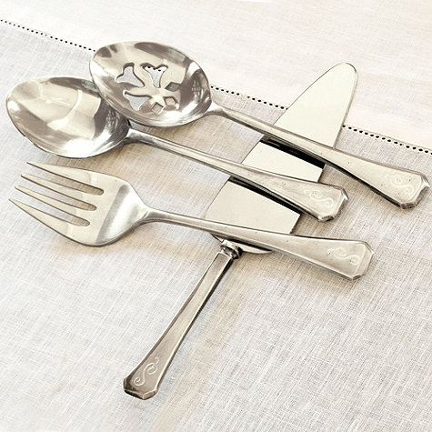 (___) (___) 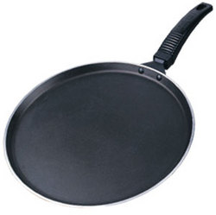 (___)(__)

Grade ________ Tr. Sign_________________
ACTIVITY SHEET CLASS-IV
LESSON-22 THE WORLD IN MY HOME
- What did Akshay’s grandmother warm him?
__________________________________________________________________________________________________________________________________________________________________
- Ritu doesn’t want to go to Meena’s house. Why?
____________________________________________________________________________________________________________
- Write an incident when there was a quarrel at your house over T.V. or something else.
____________________________________________________________________________________________________________
- Do you think it is right to have different rules for girls and boys? Why?
____________________________________________________________________________________________________________
- Were you stopped from playing with certain children? Who were they?
____________________________________________________________________________________________________________

Grade ________ Tr. Sign_________________
ACTIVITY SHEET CLASS-IV
LESSON-23 POCHAMPALLI
- How did “Pochampalli” cloth get its name?
____________________________________________________________________________________________________________
- Write all the steps from thread to Saree in brief.
________________________________________________________________________________________________________________________________________________________________________________________________________________________
- Collect pieces of five different types of clothes and paste them below. Write the types of the cloth.
Types of clothes | Name of cloth

Grade ________ Tr. Sign_________________
ACTIVITY SHEET CLASS-IV
LESSON-24 HOME AND ABROAD
- What interesting things did Shanta see from the plane?
____________________________________________________________________________________________________________
- What places did Maalu see on the globe?
____________________________________________________________________________________________________________
- Why do people cover their heads in Abu Dhabi?
______________________________________________________
- Write in detail about Abu Dhabi:
- Climate and weather: ___________________________________________________
- Currency:
___________________________________________________
- Language:
___________________________________________________
- Paste Indian currency like coin and notes.

Grade ________ Tr. Sign_________________
ACTIVITY SHEET CLASS-IV
LESSON-25 SPICY RIDDLES
- Which spice brings water in your eyes and nose?
______________________________________________________
- Name the spice used for healing wounds.
- Garam masala is made by grinding many spices together. Name at least four of them.
- Fill in the blanks:
- ________ is used to make the food look yellow.
- ________ is small and round like a pearl.
- ________ keeps the stomach healthy.
- ________ looks like a nail.
- Identify the pictures of the spices given below. Write their names.
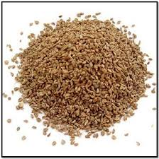 ______________ 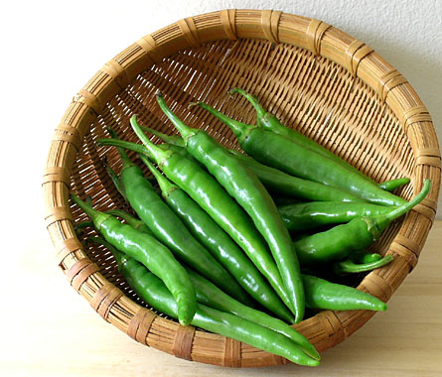 ______________
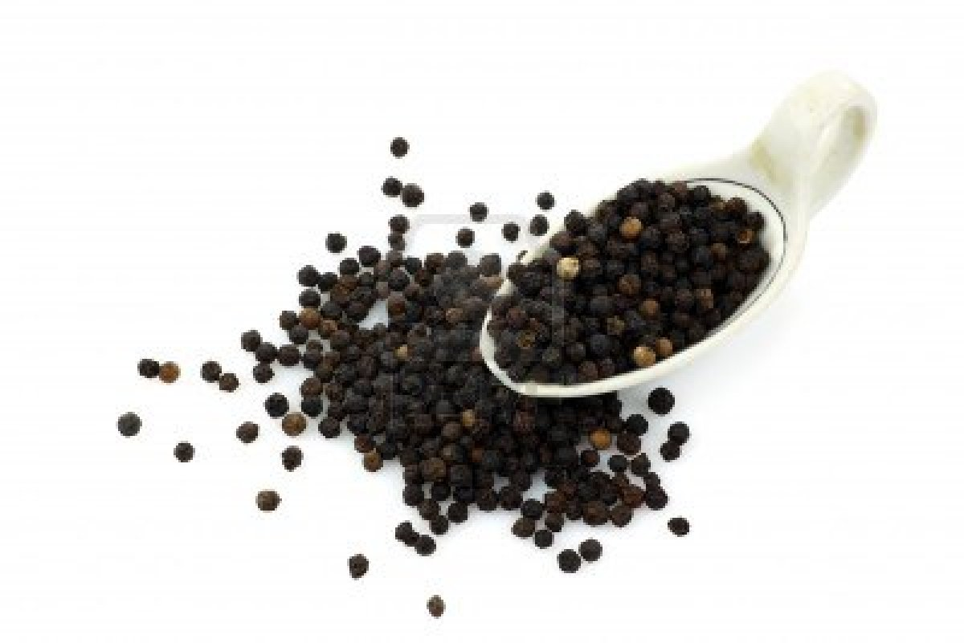 _____________ 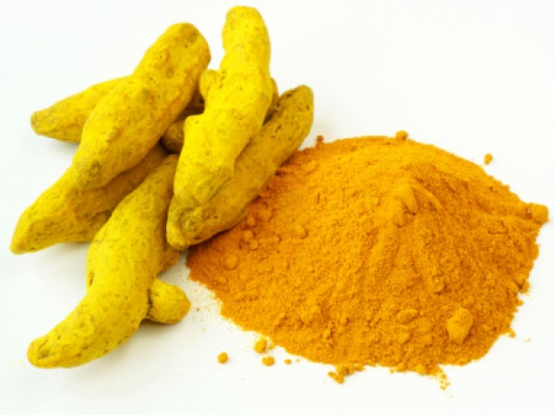 ________________
Grade ________ Tr. Sign_________________
ACTIVITY SHEET CLASS-IV
LESSON-26 DEFENCE OFFICER: WAHIDA
- Who is Wahida Prism?
______________________________________________________
- What was Wahida’s big dream?
______________________________________________________
- Fill in the blanks:
- Wahida Prism is a ________ in Indian Navy.
- She belongs to a small village called ________ in _________ district of ___________.
- Wahida took training for __________ months before joining the armed forces.
- First-aid is given on every ___________ ship.
- Wahida’s performance was reviewed for __________ years.
- Find out the difference between a normal ship and a submarine:
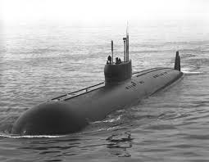
________________________________________________________________________________________________________________________________________________________________________________________________________________________________________________________________________________________________________________________
Grade ________ Tr. Sign_________________
ACTIVITY SHEET CLASS-IV
LESSON-27 CHUSKIT GOES TO SCHOOL
- Fill in the blanks:
- Chuskit is ________years old _______ who cannot ______.
- She lives in ________ village in _______.
- Abdul talked about his plan to the _________and ________.
- They made a small _______ across the river.
- Match the following:
- A person who cannot speak blind
- A person who cannot walk dumb
- A person who cannot see lame
- What was Chuskit’s dream?
______________________________________________________
- Paste pictures of any two famous people who inspired of their physical problems achieved great success in life. Write few sentences about them. [Hint: Louis Braille, Helen Keller]

__________________________________________________________________________________________________________________________________________________________________Grade ________ Tr. Sign________________

